**JavaScript File Loading inside HTML**

(default, async, defer)

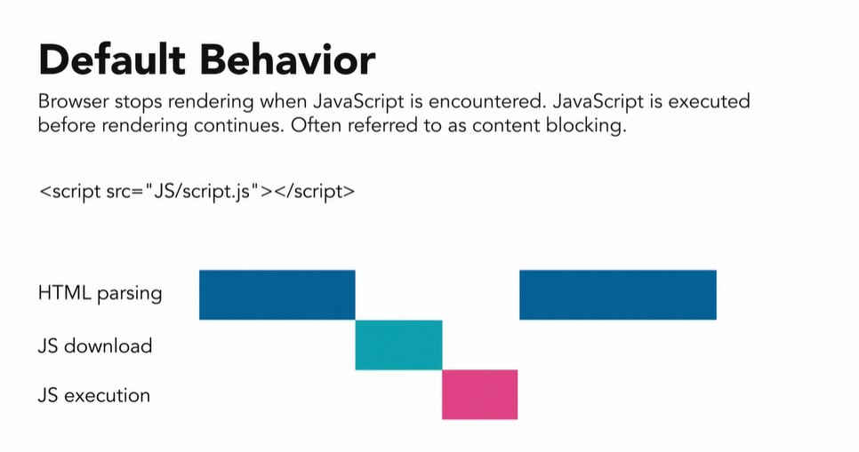

**Note :** New Standard suggested the use of async and defer.

**Source**: LinkedIn Learning <https://www.linkedin.com/learning/javascript-essential-training/modern-javascript-loading>

Author : SUBA